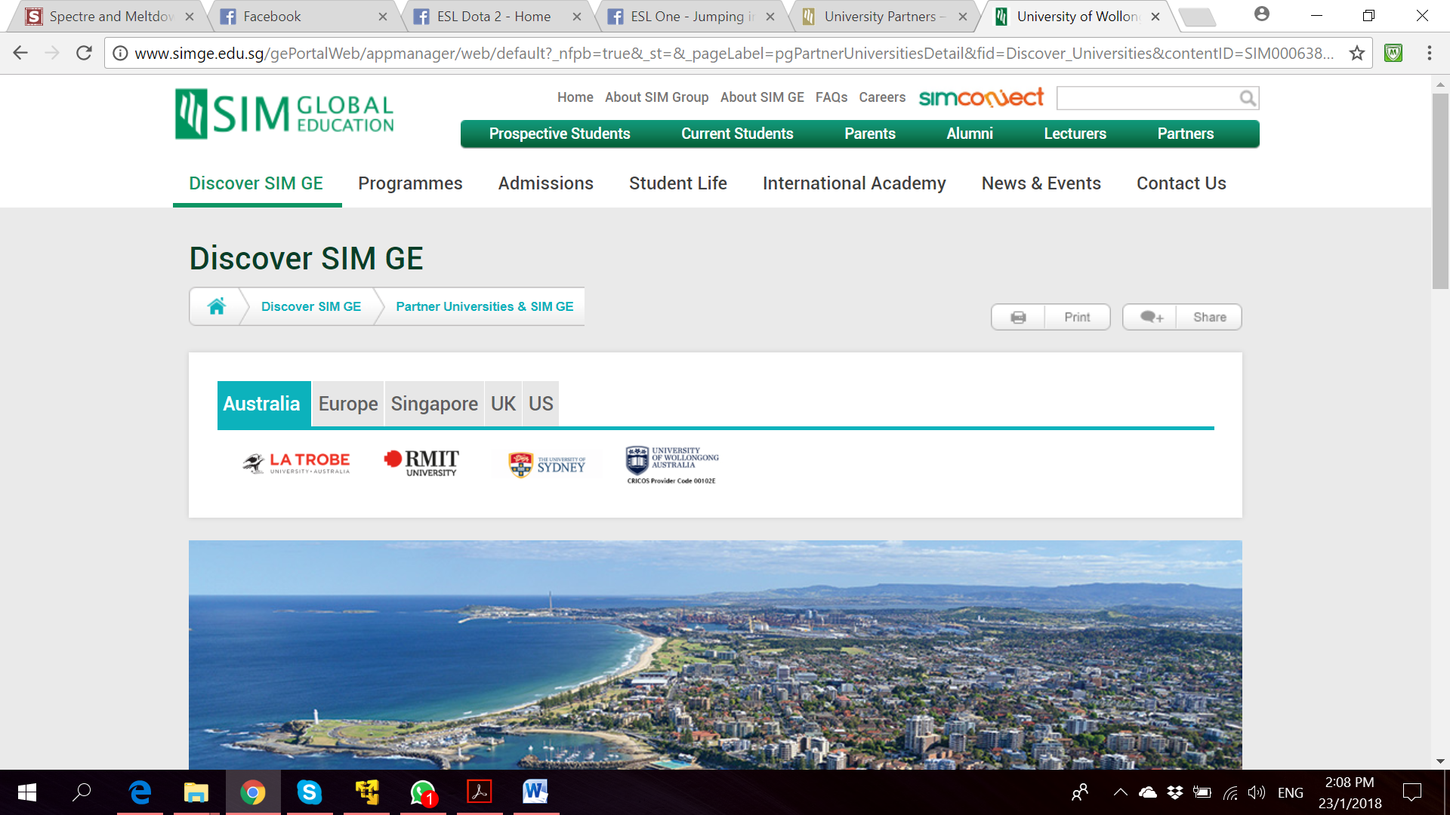

**Bachelor of Computer Science**

**(Digital System Security)**

CSCI321 – Final Year Project

Project Proposal

**Project Particulars**

|  |  |
| --- | --- |
| Supervisor | Dr Ta Nguyen Binh Duong |
| Project Group | SS18/1F |
| Project Title | Two Factor Authentication |

**Project Team’s Particulars**

|  |  |  |
| --- | --- | --- |
| Student Number | Student Name | Email Address |
| 5363536 | Koh Hong Wei | hwkoh003@mymail.sim.edu.sg |
| 5710923 | Chua Han Ming Adler | hmachua002@mymail.sim.edu.sg |
| 5711356 | Ong Wei Hao | whong012@mymail.sim.edu.sg |



**A secure file locking application**

**Document Control**

Title: Project Proposal

Document Name: FYP_ProjectProposal

**Distribution List**

|  |  |  |
| --- | --- | --- |
| Name | Title/Role | Where |
|  |  |  |
|  |  |  |
|  |  |  |
|  |  |  |
|  |  |  |

**Record of Revision**

|  |  |  |  |  |  |
| --- | --- | --- | --- | --- | --- |
| Revision Date | Description | Section Affected | Changes Made By | Version after Revision | Notes |
| 23/01/18 | Initial Setup of project proposal | - | Adler | 1.0 |  |
| 24/01/18 | Populating Data into project proposal | - | Team | 1.1 |  |
| 26/01/18 | Finalizing Project Proposal | - | Hong Wei | 1.2 | Individual Parts collated and compiled together. |
|  |  |  |  |  |  |
|  |  |  |  |  |  |
|  |  |  |  |  |  |
|  |  |  |  |  |  |
|  |  |  |  |  |  |
|  |  |  |  |  |  |
|  |  |  |  |  |  |

Table of Contents

Project Team Structure 1

Project Gantt chart 1

1. Introduction 2

1.1. Background 2

1.2. Project Purpose 2

1.3 Target Users 2

2. Market Survey 3

2.1. Market Research and Current Products 3

3. Proposed Solution 5

3.1 Proposed Features 5

3.2 Proposed Use Case 6

4. Development Methodologies 6

4.1 Waterfall Model 6

4.2 Prototyping Model 7

4.3 Agile Model 7

4.4 Rational Unified Process 7

5. Comparison 8

5.1 Application Development Language 8

5.2 Database 8

6. Risk Assessment 9

References 10

# Project Team Structure

|  |  |  |
| --- | --- | --- |
| Name | Email | Roles |
| Koh Hong Wei | hwkoh003@mymail.sim.edu.sg | Manager, Tester |
| Chua Han Ming Adler | hmachua002@mymail.sim.edu.sg | Implementer, Documenter |
| Ong Wei Hao | whong012@mymail.sim.edu.sg | Designer, Documenter |

The above team structure is implemented to clearly distinguish the area each member of the team is to focus on but it does not infer that he/she will be the only one involved in doing that task.

SmartSVN and a private GitHub repository will be use as version controlling and team collaboration tool. Each team member will have local repository which will then be merged with the central repository. All members will be working on different part of the project at a given point in time to prevent clashes when committing to central repository. All documents and source codes will be stored in this central repository.

Meeting minutes will be noted down during every meeting summarising the content of the meeting and what actions to be taken.

# Project Gantt chart

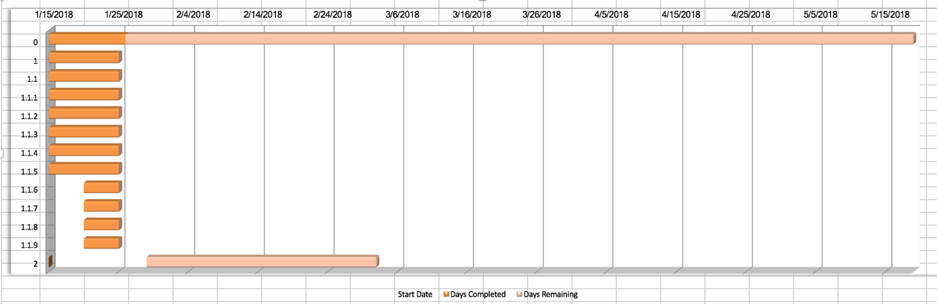

|  |  |
| --- | --- |
|  | **Task Name** |
| **0** | Full Project Time Line |
| **1** | Inception Phase 1 |
| **1.1** | Project Proposal |
| **1.1.1** | Background introduction |
| **1.1.2** | Defining project scope |
| **1.1.3** | Market Research on Current Product |
| **1.1.4** | Target User |
| **1.1.5** | Proposed Features |
| **1.1.6** | Highest Level Use Case |
| **1.1.7** | Comparison 1: Application Develop Language |
| **1.1.8** | Comparison 2: Database |
| **2** | Inception Phase 2 |

# 1. Introduction

## 1.1. Background

This project proposal was written to document the research and proposed idea for the Final Year Project entitled “Two Factor Authentication”. Impersonating others has always been an issue when it comes to cyber threat. As technology advances, using password alone is no longer as effective as before. Attackers tends to develop new ways to breech security and obtain sensitive data.

Our group is tasked to develop a two factor authentication to enhance current security authentication that are already implemented in current applications, systems or devices.

In this proposal, we will bring you through on our market research and our proposed idea.

## 1.2. Project Purpose

This project aims to provide the following to users:

* To enhance security on file management
* Provides 2 factor authentication to unlock files
* A secure vault that only allows intended users to access files

## 1.3 Target Users

According to our market research, we found our application suitable for the following group:

1. Employees in a workplace that wants to keep documents with different security level confidential from other employees using the same machine.
2. Student using school machine for assignment or homework and wants to keep it confidential from other students who might use the same machine after.
3. General public using shared machine with documents or information saved on such machine.
4. Family using a shared PC to keep their files safe and secure.

## 

# 2. Market Survey

## 2.1. Market Research and Current Products

Below are a few ways of user authentication that are already in the market and example of products in the market that are using them.

### 

|  |  |  |  |  |
| --- | --- | --- | --- | --- |
| Application | Platform | Description | Security | Features |
| 1Password | Android | This application remembers all your passwords for the user, the user would need a master password or using fingerprint authentication before being able to access the rest of the passwords | Login using master password or fingerprint authentication  Lock the app automatically to ensure data is protected, even if device is lost or stolen | Create strong, unique passwords for all online accounts  Fill usernames and passwords into websites and apps  Access information on all user’s mobile devices and computers  Share passwords securely with family or company  Unlock using fingerprint unlock |
| Authenticator Plus | Android | Authenticator Plus generates 2-step verification to protect accounts with your password and phone/tablet | Secure – 256-bit AES encryption and Pin lock for security  Automatic back/restore- accounts are automatically backed up to cloud  Fingerprint support – Unlock the app through fingerprint | Generates a 6 digit OTP after scanning QR code generate from facebook or other site. This OTP serves as a second authentication factor before being able to access to the account  Organize – group accounts with categories and re-order frequently used accounts to top |
| App Lock: Fingerprint Password | Android | A secure and easy-to-use application locker with pin, pattern or fingerprint password protection | Second authentication factor even though the user’s phone is unlock.  App Lock able to prevent others from opening locked apps, deleting or purchasing anything while on the user’s phone | Put a Pin, Pattern or fingerprint lock in front of any app on your phone like Facebook, Snapchat. When opening a protected app, App Lock will ask to confirm password the user have set to let the user in |
| Google Authenticator | iOS, Android, website | A software token that implements two-step verification using Time-based One-time algorithm and HMAC-based algorithm. | Google account (username and password)  Implements algorithm specified in RFC 6238 & 4226 | Uses QR code to register account  One google account to manage multiple 2FA applications  Password Managers  File hosting services |
| Hardware token |  | A keychain sized security token which generates OTP. Each time user logs in, user will press the button on the token to generate the OTP and the OTP will be displayed on the screen of the token. | Only generates OTP when user press on the button on the token | OTP is generated based on time and last for a certain amount of time before a new OTP will be generated upon request. |
| SMS OTP | Mobile with SIM card | SMS containing OTP will be sent to mobile phone registered. OTP sent whenever user log in with Username and Password | OTP is sent to registered mobile number. | OTP is sent via SMS to user.  OTP last a certain amount of time |
| Yubikey | NFC devices/ computer | Touch the button to trigger security based on public-key cryptography: works instantly, no need to re-type passcodes from a device — replacing SMS texts, authenticator apps, legacy tokens, and similar devices | Only allow accessing when the key is plugged in or detected by NFC. | Can be used for any accounts, by NFC or USB form. Key allows 2FA done when accessing account-based sites(fb/gmail) |

# 3. Proposed Solution

After conducting our market research, we propose a 2FA product that provides the following:

* To use this product, users are required to have a smart phone equipped with a camera.
* Each users are to initialize an account with our application.
* On the mobile application, users will be prompt to login using his/her fingerprint.
* To lock a file on the computer, run the desktop application and login using the username and password.
* Select file that the user wish to lock. A unique QR code will be produced and users are required to scan the QR code with their mobile phone.
* Using a unique cryptographic algorithm, the mobile app will produce a unique OTP that will be used to lock the file on the desktop.
* To unlock, the user does the same steps as above.

## 3.1 Proposed Features

Setting up an account

* Users will be allowed to set-up an account with us using their email address.
* Select a unique username and a password to complete registration.

Locking of File/Folder

* Files can only be locked upon logging into his/her account.
* Scanning of the QR code produced on the application with the mobile phone will produce a unique OTP.
* Enter the OTP into the application to securely lock the application

Unlocking of File/Folder

* Alike locking a file, if the user wish to unlock the file, login into the application.
* Scan the QR code produced and enter the OTP from the mobile phone to unlock the file

Secure Cryptographic Computation

* The back end of our application is securely encrypted with a cryptographic algorithm that is hard to break. Thus, allowing users to have the assurance that their files are only available to intended users.

Account Recovery

* In the unlikely event of forgetting the password, users will be able to reset their account credentials.

Trusted Users

* Users with the file rights will be able to authorize other users to access the files.

## 3.2 Proposed Use Case

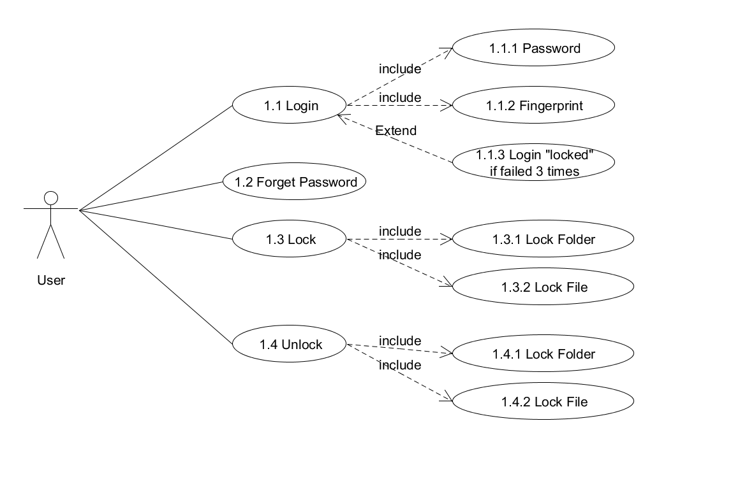

# 4. Development Methodologies

## 4.1 Waterfall Model

The waterfall model is a relatively linear sequential design development methodology. It tends to be one of the less iterative and less flexible approach to adopt. As its name suggest, it is a downwards model that flows through the different phases. By adopting this model, it is challenging and more costly to support changes once its phase has passed.



## 4.2 Prototyping Model

This model is based on requirements gathered from a user. A prototype is then built based on requirements gathered. Prototype is reviewed by the user an a new prototype is built again. This iteration repeats until the final design is confirmed and accepted by the user.

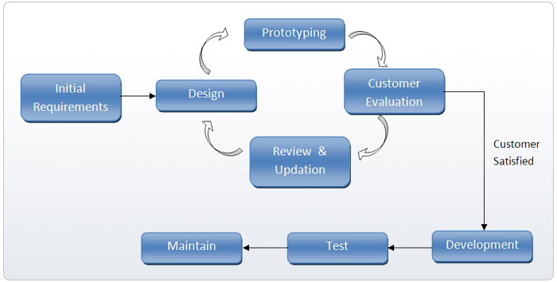

## 4.3 Agile Model

The initial planning and analysis is kept at a high level, just enough to outline the scope. After every iterations, an end product is released. At every iteration, product is refined.

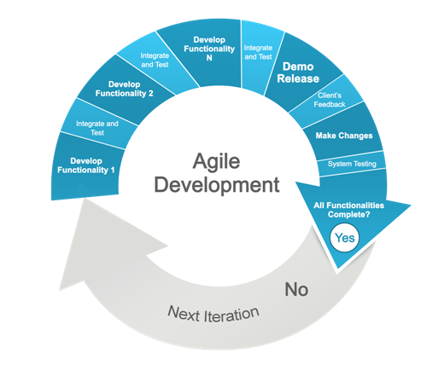

## 4.4 Rational Unified Process

RUP is an iterative software development framework. It consists of 4 main stages:

* Inception

In this phase, the scope of the project is defined.

Requirements are gathered.

Mitigate the key risk items identified through analysis.

* Elaboration

Develop detailed design of the system with diagram aids (use case diagram, activity diagram etc)

* Construction

In this phase, the actual product is being developed.

* Transition

Primary objective is to transit from development phase into production, making it ready for the market. This phase includes testing the system and providing training to its user.

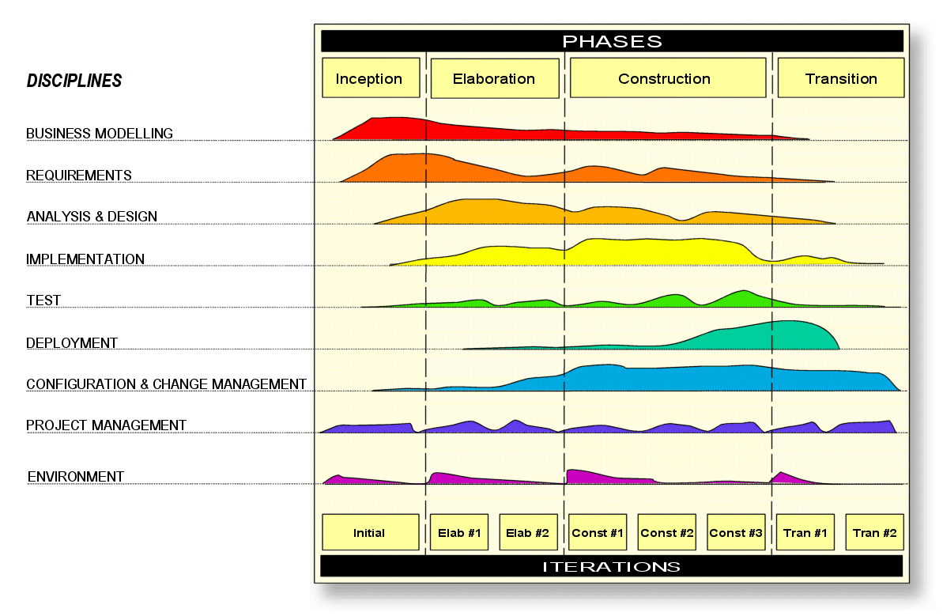

RUP allows more than one iterations for each of the 4 stages, providing flexibility when changes are required during development phase.

After much considerations, we have decided to adopt the RUP development methodology.

# 5. Comparison

## Application Development Language

|  |  |  |
| --- | --- | --- |
| Language | IDE | Description |
| C++ | QT | C++ is a general purpose object oriented programming language. Provides a collection of predefined classes. Android applications can also be developed using C++ using QT libraries. However, the size required for the package will be significantly larger |
| Java | Android SDK, Eclipse | Android applications are usually developed in Java or Kotlin. Java is also the official programming language for using android studio |

## Database

|  |  |
| --- | --- |
| Relational Database | Non Relational Database |
| Structured Query Language (SQL) | No SQL |
| Fixed Schema | No fixed schema |
| Table relationships makes queries more resource intensive (foreign keys) | Stores as individual entries. |
| Able to handle complicated querying and database transactions | Does not handle transactions |

# 6. Risk Assessment

|  |  |
| --- | --- |
| Risks | Description |
| Project delay | Bugs and error along the way during the implementation |
| Anyone is able to unlock the file/folder | QRCODE is universal so it is open for use by anybody with a QRCODE scanner |
| App crash | Application unable to open and thus unable to start and run to scan |
| Leaking of information | As QRCODE is encrypted with username and password, if the QRCODE is decrypted when hacked, the username and password will be known |
| Database stop working | Database SQL may have its services stop or crash and unable to carry on further actions. |

# References

<https://en.wikipedia.org/wiki/Google_Authenticator#Pseudocode_for_one-time_password_(OTP)>

<https://www.csa.gov.sg/gosafeonline/go-safe-for-me/homeinternetusers/2fa-the-use-of-otp-token>

<https://www.yubico.com/products/yubikey-hardware/fido-u2f-security-key/#toggle-id-10>

<https://www.computerworld.com/article/3063544/android/android-apps-fingerprint-support.html>

<https://play.google.com/store/apps/details?id=com.agilebits.onepassword>

<https://play.google.com/store/apps/details?id=com.mufri.authenticatorplus>

<https://play.google.com/store/apps/details?id=com.getkeepsafe.applock>

<https://www.pluralsight.com/blog/software-development/relational-non-relational-databases>